H.T No
Regulations:
A20

Sreenidhi Institute of Science and Technology
(An Autonomous Institution)
Code No:8KC81 Date: 14-Aug-2024 (AN)

B.Tech III-Year I- Semester External Examination, August-2024 (Supplementary)
STRUCTURAL ANALYSIS (CIVIL)

Time: 3 Hours Max.Marks:70

Note: a) No additional answer sheets will be provided.
b) All sub-parts of a question must be answered at one place only, otherwise it will not be valued.
c) Missing data can be assumed suitably.

Bloom's Cognitive Levels of Learning (BCLL)

Remember | L1 | Apply | L3 | Evaluate | L5
Understand | L2 | Analyze | L4 | Create | L6

Part - A Max.Marks:20
Answer all QUESTIONS

 |  | BCLL | CO(s) | Marks
1 | Define static and kinematic indeterminacies along with examples. | L1 | CO1 | [2M]
2 | Mention the fixed end moments of beam subjected to moment M at a distance a from left support. | L2 | CO2 | [2M]
3 | What are the assumptions made in the slope deflection method? | L1 | CO3 | [2M]
4 | Explain the concepts involved in the moment distribution method. | L3 | CO4 | [2M]
5 | What are the limitations of Kani's Method? | L1 | CO5 | [2M]
6 | How are Influence Line Diagrams helpful in bridge design? | L3 | CO6 | [2M]
7 | Find out the kinematic indeterminacy of rigid jointed space structure | L2 | CO1 | [2M]
8 | Mention the reasons due to which sway may occurs in portal frames. | L2 | CO3 | [2M]
9 | What is the difference between an Influence Line Diagram and a Shear Force Diagram (SFD) or Bending Moment Diagram (BMD)? | L1 | CO5 | [2M]
10 | Define rotation factor. | L1 | CO6 | [2M]
Part – B Max.Marks:50
ANSWER ANY FIVE QUESTIONS. EACH QUESTION CARRIES 10 MARKS.

 |  |  | BCLL | CO(s) | Marks
11. |  | Find the slope and deflection of a propped cantilever beam subjected to an UDL of 25kN/m over a span of 6m. | L5 | CO1 | [10M]
12. |  | A fixed beam of 8m span is loaded with a point load of 160 kN at distance of 2m from support A. Draw the shear force and bending moment diagrams. | L5 | CO2 | [10M]
13. |  | Analyze the beam show in figure by slope deflection method and draw BMD. (EI is uniform throughout the beam.  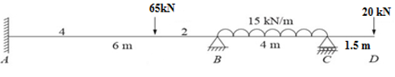 | L5 | CO3 | [10M]
14. |  | Analyze the beam shown in figure using Moment Distribution method.  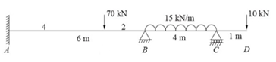 | L4 | CO4 | [10M]
15. |  | Analyze the beam shown in figure using Kani’s method.  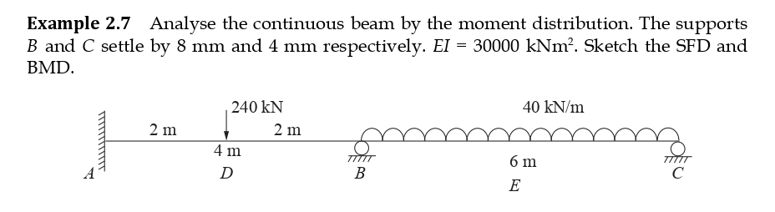 | L4 | CO5 | [10M]
16. |  | An uniformly distributed load of intensity 40 kN/m, 6 m long crosses a simply supported girder of span 25 m from left to right. Calculate the maximum positive and negative shear forces at a section 10 m from the right support. | L5 | CO6 | [10M]
17. | a) | Write a short note on static indeterminacy with example. | L2 | CO1 | [4M]
 | b) | Calculate the fixed end moment at left and right support in a fixed beam of span 4m carrying 15kN/m UDL throughout the span. | L2 | CO2 | [3M]
 | c) | Write a short note on sinking of supports of continuous beams. | L2 | CO3 | [3M]
18. | a) | What are the advantages of continuous beams over simply supported beams? | L2 | CO4 | [4M]
 | b) | What are the advantages of Kani’s method over slope deflection and moment distribution methods? | L2 | CO5 | [3M]
 | c) | What is an influence lune diagram (ILD) and how are these useful in structural analysis? | L2 | CO6 | [3M]
-- 00 -- 00 –

